

**Take Part in Our Survey!**

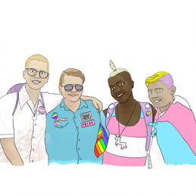

Take part in the ICTA Survey!

* What do trans people want from NHS and other health services?
* How can health services work better together to meet the needs of trans (including non-binary) people?

We are looking for trans people to take part in our anonymous survey looking at your experiences of healthcare.

To do the survey online, go to:

<http://www.thissurvey.com/icta>

This survey should take about 20 minutes to complete, and at the end you will be asked if you are interested in doing a follow up interview, either online or by telephone. Some of these interviews will be for case studies of particular healthcare services, including GICs.





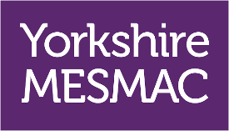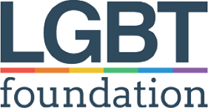

ICTA (Integrating Care for Trans Adults) is a research project funded by the National Institute for Health Research. We are a partnership of academic, NHS and voluntary sector organisations. Trans people are well represented on the ICTA Project team. To find out more, go to:

<http://business-school.open.ac.uk/research/projects.icta>

If you prefer a paper version of the survey, just email your name and address to Ev Callahan at [evelyn.callahan@open.ac.uk](mailto:evelyn.callahan@open.ac.uk) or give Ev a call on 01908 858 185. Ev will post you a survey in a prepaid return envelope and will delete your name and address once they’ve done so. Ev is also happy to answer any questions you have about ICTA or the survey. They can also arrange any support you need to complete the survey. Just drop them a line.

This survey and the ICTA project as a whole have been reviewed and approved through the Health Research Authority, the NHS East Midlands – Leicester Central Research Ethics Committee (ref 19/EM/0289, IRAS ID 262467), and the Open University Human Research Ethics Committee (HREC/3141/Holti).

